Ash Wednesday Prayer at Home 2021

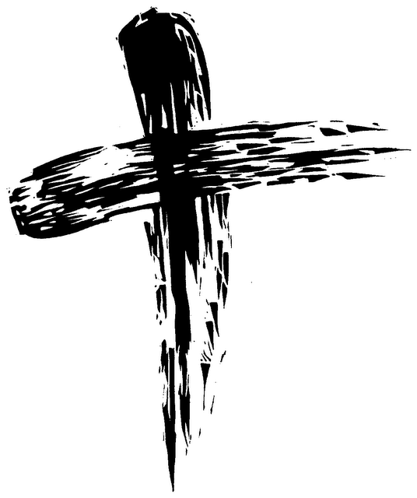

Remember that you are dust, and to dust you shall return. Turn away from sin and be faithful to Christ.

Lent is a time when we, as individuals and as a community of disciples, remember who we are; creatures with a mortal body, who are living in a world which is also limited by time and mortality, but called to a pilgrimage, following Jesus who was crucified but raised beyond this earth to eternal life.
The words used when we are marked with ashes (often from the Palm crosses of the previous year) remind us of this calling and our Lenten pilgrimage. This year we cannot join together physically on Ash Wednesday to be marked as a community seeking to follow Christ, but we are still that community and can still reflect on the pilgrimage we are called to.
These ideas are suggestions of how you might mark Ash Wednesday at home. There is a lot here because different people pray differently so there are ideas for you to chose from rather than do each one of them.

Washing Hands.
This year we have been washing hands a lot. We were encouraged to sing Happy Birthday twice but singing a couple of verses of a hymn gets the job done just as well. This might be a good one for Ash Wednesday.

1.Dear Lord and Father of mankind, forgive our foolish ways:
reclothe us in our rightful mind; in purer lives your service find,
in deeper reverence praise,

6 Breathe through the heats of our desire your coolness and your balm;
let sense be dumb, let flesh retire, speak through the earthquake, wind and fire,
O still small voice of calm, O still small voice of calm!

This washing (which we have been doing all year as a commitment to preserve life) is also a sign of our sorrow for sins and mistakes and God’s promise to wash away and forgive our sins. As a prayerful activity you could wash your hands and pray from the psalms.

Have mercy on me, O God, according to your steadfast love;
according to your abundant mercy blot out my transgressions.
Wash me thoroughly from my iniquity, and cleanse me from my sin.
Create in me a clean heart, O God,
and put a new and right spirit within me.
Do not cast me away from your presence,
and do not take your holy spirit from me.
Restore to me the joy of your salvation,
and sustain in me a willing spirit. From psalm 51

Create your own ash
This is a bit high risk but if you burn an old palm cross from last year outside and in a metal container you might be able to create a bit of ash for Ash Wednesday safely. Perhaps mark a palm or the back of the hand with ash. Do not mix the ash with water as creates an alkaline substance which will burn. In church we mix the ash with oil so it sticks. If you are crafty you might want to mix the ash with PVA glue and paint a stone which can be left somewhere you can see it every day. Mixing the ash with glue means it has a tactile quality which may become a prayer focus.

Prayers for Ash Wednesday
The collect for Ash Wednesday from the Book of Common Prayer
ALMIGHTY and everlasting God, who hatest nothing that thou hast made, and dost forgive the sins of all them that are penitent: Create and make in us new and contrite hearts, that we worthily lamenting our sins, and acknowledging our wretchedness, may obtain of thee, the God of all mercy, perfect remission and forgiveness; through Jesus Christ our Lord. Amen.

In Common Worship we pray
We have not loved you with our whole heart.
We have not loved our neighbours as ourselves.
In your mercy
forgive what we have been,
help us to amend what we are,
and direct what we shall be;
that we may do justly,
love mercy,
and walk humbly with you, our God.
Amen.

What do you want to say sorry for?
In the silence remember you are human and make mistakes?

Very truly, I tell you, unless a grain of wheat falls into the earth and dies, it remains just a single grain; but if it dies, it bears much fruit. Those who love their life lose it, and those who hate their life in this world will keep it for eternal life. John 12. 24-25

Dust
One of the gospels set for Ash Wednesday is this passage.
Read it through then find some soil, of compost (or even dust on a windowsill!)
Jesus went to the Mount of Olives. Early in the morning he came again to the temple. All the people came to him and he sat down and began to teach them. The scribes and the Pharisees brought a woman who had been caught in adultery; and making her stand before all of them, they said to him, ‘Teacher, this woman was caught in the very act of committing adultery. Now in the law Moses commanded us to stone such women. Now what do you say?’ They said this to test him, so that they might have some charge to bring against him. Jesus bent down and wrote with his finger on the ground. When they kept on questioning him, he straightened up and said to them, ‘Let anyone among you who is without sin be the first to throw a stone at her.’ And once again he bent down and wrote on the ground. When they heard it, they went away, one by one, beginning with the elders; and Jesus was left alone with the woman standing before him. Jesus straightened up and said to her, ‘Woman, where are they? Has no one condemned you?’ She said, ‘No one, sir.’ And Jesus said, ‘Neither do I condemn you. Go your way, and from now on do not sin again.’ John 8.1-11

I wonder what Jesus wrote in the dust?
I wonder what you would have liked to read if you had been there. Or might it have been a sign, a symbol?

Rowan Williams was in New York the day the Twin Towers were attacked and wrote a short book reflecting on this event which is called “Writing in the Dust”. This is how he ends the book:
But lastly, another picture from the Gospel of John evoked for me by all this, from the stray story of Jesus and the women taken in adultery that is preserved, improbably, in John 8. When the accusation is made, Jesus at first makes no reply but writes with is finger on the ground. What on earth is he doing? Commentators have had plenty of suggestions, but there is one meaning that seems to me obvious in the light of what I think we learned that morning (11th Sep 2001) her hesitates. He does not draw a line, fix an interpretation, tell the woman who she is and what he fate should be. He allows a moment, in which people are given time to see themselves differently precisely because he refuses to make the sense they want. When he lifts his head there is both judgement and release. So this is writing in the dust because it tries to hold that moment for a little longer, long enough for some of our demons to walk away. Writing in the Dust R Williams p80-81

Lent is time when we are allowed a moment, a time and space to see ourselves differently, and to allow words from God to become part of our lives.
Can we have the courage to hold onto
space,
silence,
uncertainty
and allow God to be God

God our Father and Mother,
you create us from the dust of the earth:
grant that this dust may be for us
a sign of our penitence
and a symbol of our mortality;
and that the buds bursting and plants growing
may be a sign of the new life you offer us all through the life and death of Jesus
for it is by your grace alone
that we receive eternal life
in Jesus Christ our Saviour. Amen.

Planting Seeds
Find some soil, a pot of compost for a plant.
If it is in a garden or a park, wood etc, look at all the dead leaves, plants, twigs which are part of the soil, and gradually breaking down to make it good to grow new plants. Our world depends on everything that has lived becoming dust and a fertile place for new life to grow.
If this is your garden, you may want to clear some weeds, or even plant something, or sow some seeds. If you have a pot of compost you may want a plant to put in it and watch it grow during Lent, or plant some seeds as a reminder of the new life that grows from the soil and dust that is needed for it to be grow good roots.
What do you want or need to grow good roots?
How might you help those roots to grow this Lent?

A Walk
As we enter the season of Lent, we desire to follow Jesus, to grow in discipleship and in faith. It is not just personal sins we repent of, but also a recognition that being human means to be imperfect.
To be part of a community is to be part of a community that is not perfect.
If you are outside, or going for a walk, look for paths that others have trodden. See the footprints of different people. There might be two tracks.
How will you choose which to follow?
Which foot prints will be your guide?

With thanks to Revd Rosalind Rutherford who created the liturgy which was adapted by Revd Karen

